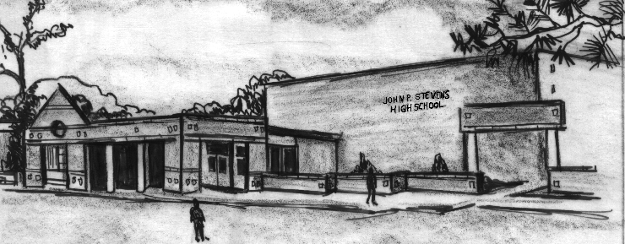
John P. Stevens High School
855 Grove Avenue
Edison, NJ 08820
Phone 732-452-2811 FAX 732-452-9529
CEEB # 310787

Administrators
Paul Saxton, Superintendent of Schools
Gail Pawlikowski, Principal
Meredith Quick, Assistant Principal
Dr. Anthony Shallop, Assistant Principal
Robert Urbanovich, Assistant Principal
Ojas Ray, Assistant Principal

Supervisor
Brian Glassberg

Counselors
Valerie Clayton Stephen Miller
Karen Cundari Maria Randazza
Christen DeSimone Elissa Rinaldi
Shaheda Hall Pierre Salme

Lisa Lin

College Counselors
Susan Nadel Janine Silberberg

Community Edison is a 32 square mile township in northern Middlesex County, just north of New Brunswick and Rutgers University, and 25 miles southwest of New York City. It is a diverse community with many commuters to Newark and New York. Many of the more than 100,000 residents enjoy an above average socio-economic level. A high percentage of parents are college graduates and are employed in a wide variety of occupations that encompass many managerial and professional positions.

School John P. Stevens High School is a comprehensive four year high school situated in residential North Edison with approximately 2,500 students. The graduating class of 2019 consists of 595 students. John P. Stevens High School has a very strong academic program and an outstanding co-curricular program, encompassing athletics, drama, forensics, student government, music, the fine arts, and several volunteer and service organizations.

John P. Stevens High School was built in 1964 with additions completed in 1968, 1992, 2001, 2003 and 2010. The average class size is 25. The faculty consists of 175 teachers, approximately 60% of whom have Masters, 1% of whom have Doctorates. There are four administrators, nine school counselors, two college counselors, PATH Counselors, and a special services team. The faculty is quite sophisticated, well-traveled and take advantage of living in a large metropolitan area. They participate in evening and summer study programs, in-service courses, and professional meetings.

Accreditation John P. Stevens High School is accredited by the New Jersey Department of Education.

Curriculum Edison Township students are required to successfully complete four years of English, Mathematics, and Physical Education, three years of History and Science, two years of World Language, as well as one year of Visual and Performing Arts, one year of Career Education and Consumer, Family and Life Skills, and 2.5 credits of Financial Literacy. Elective subjects are offered in World Languages, Business, Music, Fine Arts, Family and Consumer Sciences and Technology Education. The three major levels of grouping are: Advanced Placement or Honors, Accelerated (1) and Regular (2). Advanced Placement courses are available in English, French, Spanish, Chinese, U.S. History, World History, American Government, European History, Economics, Calculus, Statistics, Computer Science, Biology, Studio Art, Chemistry, and Physics. The highest math class is Applied Calculus.

SAT and Advanced Placement
2018 Testing Results Last May, J. P. Stevens administered the Advanced Placement Examinations to 781 students. Of the 1816 grades reported, 595 had scores of five, 613 had scores of four, 398 had scores of three, 158 had scores of two, and 52 had scores of one.

Cr. Reading Math Total
17-18 16-17 17-18 16-17 17-18
National *** 538 *** 533 ***
State *** 539 *** 537 ***
JPS 630 628 680 648 1310
*** Data available at a later time.

College Admission Traditionally, more than 90% of our students go on to two and four year colleges. 82% of the Class of 2018 attended four year colleges and 15% attended two year colleges. The Class of 2019 has 24 National Merit Scholarship Semi-Finalists. Our students are awarded notable scholarships and attend the most prestigious schools in the country.

Class Rank According to B.O.E. Policy 6147.1, class rank shall not be reported or released except if absolutely necessary for specific scholarships (including corporate), honor societies and service academies. A weighted GPA will be reported on the transcript.

Grading System

Quality Point Values
Letter  Grade | Proficiency  Rank | Numerical Value | Honors (H) | Accelerated (1) | Regular (2)
A+ | Outstanding | 97-100 | 6.33 | 5.33 | 4.33
A | Outstanding | 93-96 | 6.00 | 5.00 | 4.00
A- | Outstanding | 90-92 | 5.67 | 4.67 | 3.67
B+ | Good | 87-89 | 5.33 | 4.33 | 3.33
B | Good | 83-86 | 5.00 | 4.00 | 3.00
B- | Good | 80-82 | 4.67 | 3.67 | 2.67
C+ | Satisfactory | 77-79 | 4.33 | 3.33 | 2.33
C | Satisfactory | 73-76 | 4.00 | 3.00 | 2.00
C- | Satisfactory | 70-72 | 3.67 | 2.67 | 1.67
D | Poor | 65-69 | 1.00 | 1.00 | 1.00
F | Unsatisfactory | 0-64 | 0.00 | 0.00 | 0.00

TRANSCRIPT CODES
N - No Grade P- Pass
WF/WP - Withdrawal Fail/Pass - No Credit
M - Medically Excused
I - Incomplete

Summer School Codes
2 - Failure Makeup
5 - No Credit - Attendance Violation
6 - Credit Completion Summer School
Students must earn 130 credits to graduate.

A GPA is computed for each student at the end of the second, fourth, sixth and eighth semesters. Only courses taken in the high school during the regular school year are included in the weighted GPA. A quality point value is assigned to each letter grade and then is multiplied by the number of credits received for each course. The sum is divided by the number of credits. This weighted GPA is reported on the transcript. 6.05 is the highest GPA that can be attained.
Students who have taken all their high school courses in Edison and/or other high schools in New Jersey (public/parochial/private) receive a weighted GPA and are included in the GPA Distribution Chart. Students from outside New Jersey who transfer to Edison following their first marking period of the junior year are not included. The transcript includes information pertaining to classes taken at the previous high school(s) at the time of transfer. Additionally, all high school courses taken in Edison are included.

John P. Stevens High School Class of 2019 Sixth Semester Weighted GPA Distribution Chart (n=577)
